

|  |
| --- |
| Assignment [1] |
| NUR SYUHAIDAH BINTI ISMAIL [CB13006] |
| Section [02] |

**BCS2333 SOFTWARE PLANNING & REQUIREMENT WORKSHOP 2013/2014/1**

**LIST OF CONTENT**

|  |  |  |
| --- | --- | --- |
| BIL | TITLE | PAGE |
| I | **QUESTIONS** | 1 |
| 1.0 | **4 major software project management phases** | 2 |
| 2.0 | **Create a WBS for the following projects:**  1.2 Putting together your favorite dinner dish – fried mee  1.3 Building a wooden picture frame  1.4 Creating software that computes the average of a set of numbers and then displays the result | 3 - 6 |
| 3.0 | **REFERENCES** | 7 |

|  |  |  |  |  |  |
| --- | --- | --- | --- | --- | --- |
| logoUMP | **FAKULTI SISTEM KOMPUTER & KEJURUTERAAN PERISIAN** | | | | **MARKAH:**    / 10 |
| **MATAPELAJARAN:** SOFTWARE PLANNING AND REQUIREMENT WORKSHOP | | | |
| **TOPIK:** WBS | **KOD:** BCS2333 | | |
| **PENILAIAN:** Assignment | **BIL:** 1 | | **MASA:** 3 Hours |
|  | | | | | |
| **NO MATRICES** : CB13006  **Instructions:**   1. This work should be done individually. But you are allowed to discuss with your colleague. 2. All your assumption and work (including your calculation, if any) must be clearly stated in this lab sheet. 3. Submit softcopy at the end of lab session.   **Questions**   1. Discuss the 4 major software project management phases? (10 marks) 2. Create a WBS for the following projects: (30 marks)   a. Putting together your favorite dinner dish – fried mee  b. Building a wooden picture frame  c. Creating software that computes the average of a set of numbers and then displays the result | | |  | | |

Page **1** of **7**

*Discuss the 4 major software project management phases? (10m)*

Most software methodologies nowadays include these 4 phases which are planning, design, implementation, and maintenance. These four phases have several naming where in some case; they are called POMA, which stands for Planning, Organizing, Monitoring and Adjusting. Below are the elaborations of respective four phases:

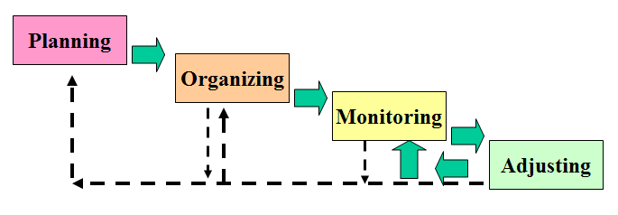

**Figure 1: The POMA management process**

**Planning Phase**

Consists a set of activities that will deliver of a plan at the end of this phase. The plan includes the following items:

* The description of the software product in the form of software artifact contents and deliverables.
* The software project attributes.
* The schedule required to complete the project.
* The types of and amount of resources needed to meet the project schedule.
* The risks associated with the project.

Page **2** of **7**

**Organizing Phase**

This phase seeks the optimum methodologies, software development, supports, and service organization suited for the software project to be made. Below are the lists of activities occurring during this phase:

* Acquiring the various skilled individuals required.
* Define process and methodologies to be utilized throughout the project.
* Obtain a set of tools that will supports the process and the methodologies.
* Creating a well-defined set of metrics to track and gauge the project.

**Monitoring Phase**

This phase usually involves a big number of people where monitoring is required to managed peoples and their respective roles. Below are the lists of activities focused in this phase:

* Consistently and regularly collecting measurements
* Analyzing the data
* Representing and presenting the data for a defined set of reports
* Making projections and making recommendations based on the analysis of the data

**Adjusting Phase**

This phase is prior to post-monitoring phase, whereby proper adjustments are made to meet requirements. This includes changes and version release to either improve or fixing bugs from the project software. It will be deciding whether is it allowed to be adjust, what can or should we adjust, and how often should we adjust prior to the project team decision.

Page **3** of **7**

*Create a WBS for the following projects: (30m)*

**

*a. Putting together your favourite dinner dish – fried mee*

**Heat cooking oil**

**Garlic, Chili & onion**

**Bahan Perenceh**

**Sprinkle of salt & spice**

**Prepare Fried Mee**

**Cook Chicken**

**Cook Beanspruot**

**Cook noodle & meat, vegetable**

**Fry mee**

**Preparing Fried Mee**

**Prepare soy sauce**

**Prepare sauce**

**Slice of spring onion**

**Eat Fried Mee**

**Finishing**

**Slice of tomato & cucumber**

Page **4** of **7**

**

*b. Building a wooden picture frame*

Prepare saw, set square

Prepare wooden sticks

Prepare tools, materials

Prepare glue

Saw 2 pair of same length

Prepare base

Building Wooden Picture Frame

Groove 45° angles on all wooden ends

Glue wooden stick to its pair

Forming frame

House frame to its rabbet

Page **5** of **7**

**

*c. Creating software that computes the average of a set of numbers and then displays the result*

Obtain inputs

Input

Calculate number of inputs

Calculate sum counts of number

Average Number

Process

Output

Display result

Page **6** of **7**

**References**

<http://www.ehow.com/list_6821857_phases-software-project-management.html>

<http://www.foundationcoalition.org/home/FCVersion2/professional/210/Oct01-Day2-Proj-Man.pdf>

Page **7** of **7**